Theme Development

03 Theme dev

Place holder Screenshot

Tony Evans

See next page for screenshots of what your page should look like

In this folder you can see the following:

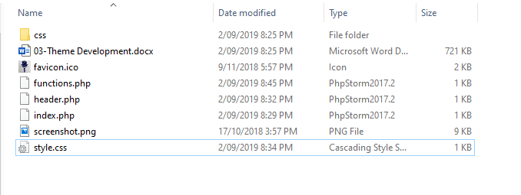

The files in this folder are again similar but this time includes a “favicon.ico” file.

# Favicon

This little icon will be displayed in your browser tab.

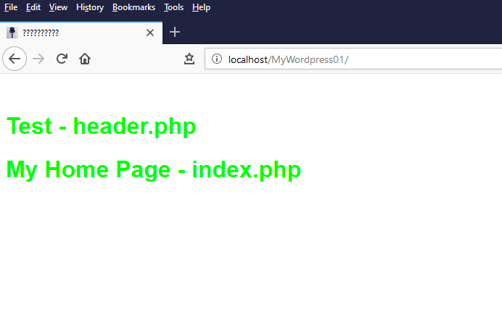

This little icon provides quite a bit of functionality. It provides a professional look to your site and provides a way for mobile users to add the website to their home screen just like an app.

There are many sites that show you how to add to home screen. The link below shows how to do this for Android, iOS and Windows Phone.

<https://www.howtogeek.com/196087/how-to-add-websites-to-the-home-screen-on-any-smartphone-or-tablet/>

Open the “functions.php” file and look at the commented section under the style enqueue function. It should look like the following screenshot.

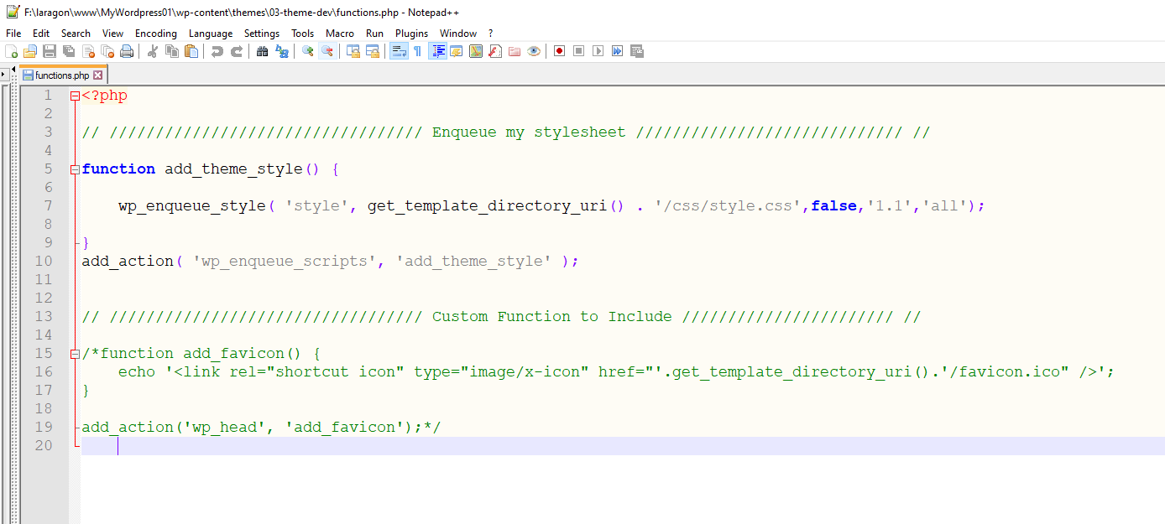

Now un-comment the “add_favicon” function to look like the following:

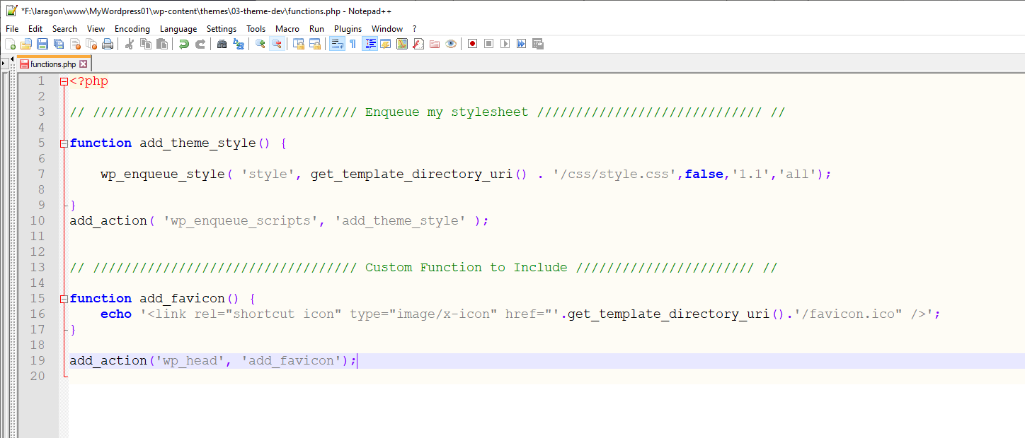

Save and now go to your browser and refresh. You should now see the “Favicon” in your browser tab.

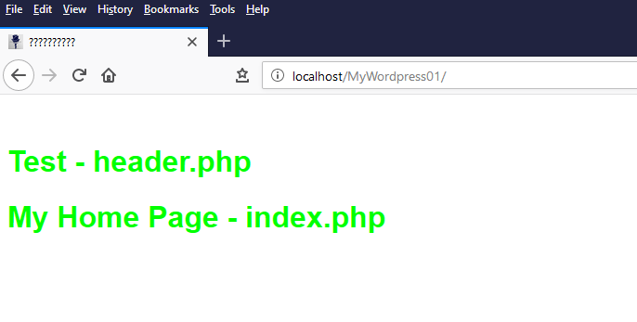

If you have this on your hosted domain name, you should be able to also view this on your mobile and add the site to your desktop window with a nice icon that looks like an app.

# Menus

WordPress Handbook says to start a menu with the following:

“To start adding a menu to your site you will need to edit the “functions.php”. You need to register your menu or menus if you want more than one. This sets the name that will appear at **Appearance -> Menus**.”

<https://codex.wordpress.org/Navigation_Menus>

For this exercise we will do this without adding anything into the “functions.php” file.

We can start to work on the next steps. See 04-Theme Development